Date and Time functions

1. Write a query to display the first day of the month (in datetime format) three months before the current month.

Sample current date : 2014-09-03

Expected result : 2014-06-01

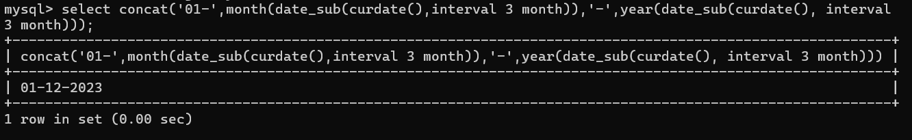

1. Write a query to display the last day of the month (in datetime format) three months before the current month.

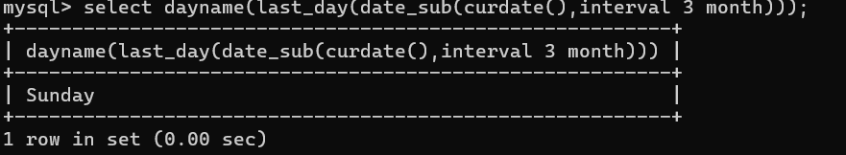

1. Write a query to get the distinct Mondays from hiredate in emp tables.

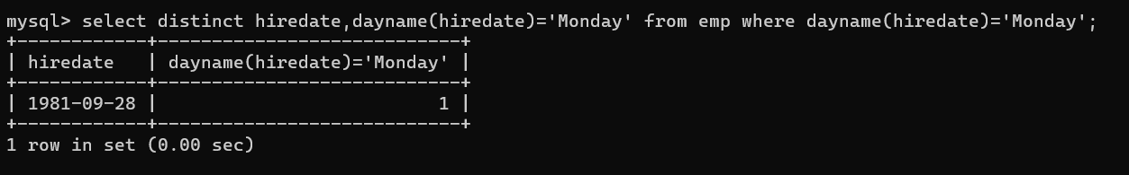

1. Write a query to get the first day of the current year.

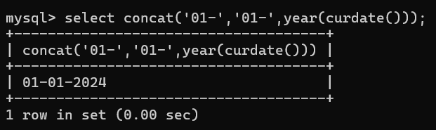

1. Write a query to get the last day of the current year.

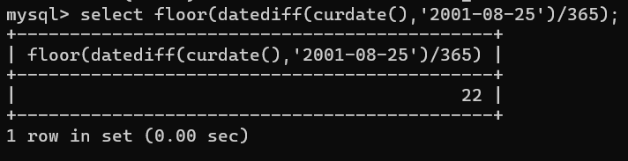

1. Write a query to calculate your age in year.

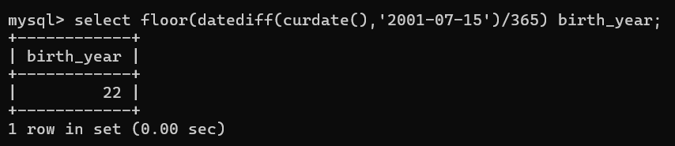

1. Write a query to get the current date in the following format.

Sample date : 04-sep-2014

Output : September 4, 2014

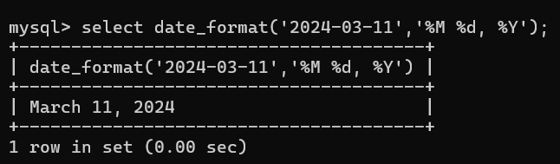

1. Write a query to get the current date in Thursday September 2014 format. Thursday September 2014

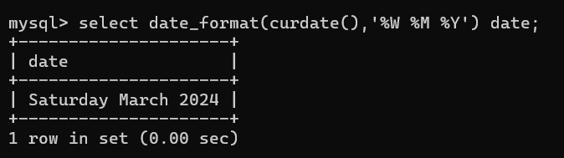

1. Write a query to extract the year from the current date.

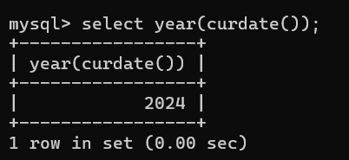

1. Write a query to get the first name and hire date from employees table where hire date between '1987-06-01' and '1987-07-30'



1. Write a query to display the current date in the following format. Sample output: Thursday 4th September 2014 00:00:00

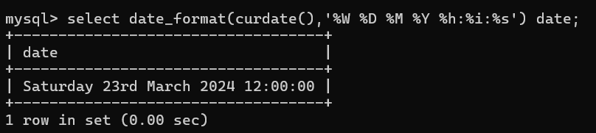

1. Write a query to display the current date in the following format. Sample output: 05/09/2014

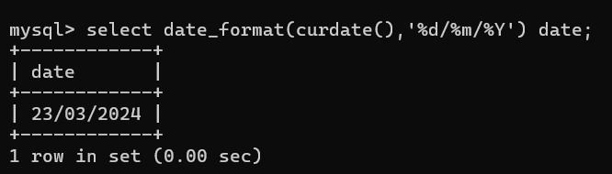

1. Write a query to display the current date in the following format. Sample output: 12:00 AM Sep 5, 2014

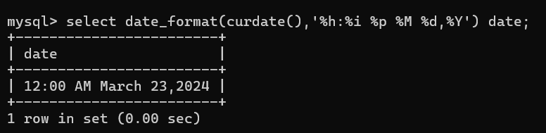

1. Write a query to get the employees who joined in the month of June.

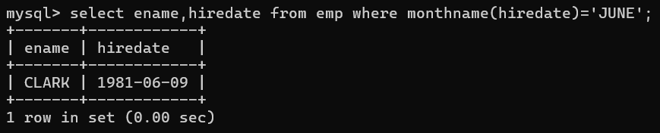

1. Write a query to get the years in which more than 10 employees joined.

**select year(hiredate),deptno from emp group by deptno**

**having count(*);**

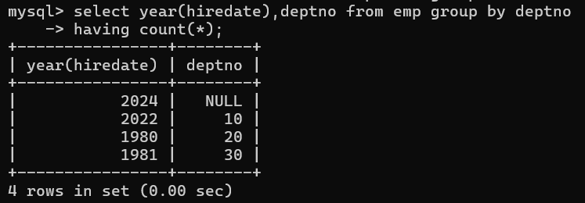

1. Write a query to get first name of employees who joined in 1987.

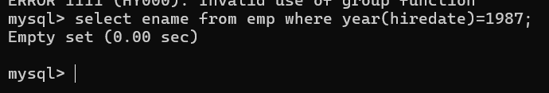

1. Write a query to get employees whose experience is more than 5 years.

**select empno,ename from emp where floor(datediff(curdate(),hiredate)/365)>5;**

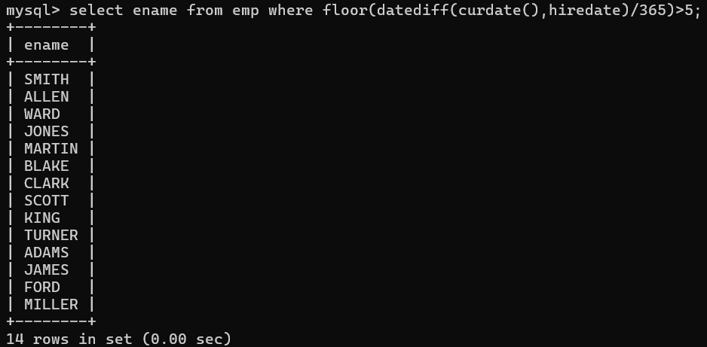

1. Write a query to get employee ID, last name, and date of first salary of the employees.

**select empno,ename,hiredate, date_add(hiredate,interval 1 month) from emp;**

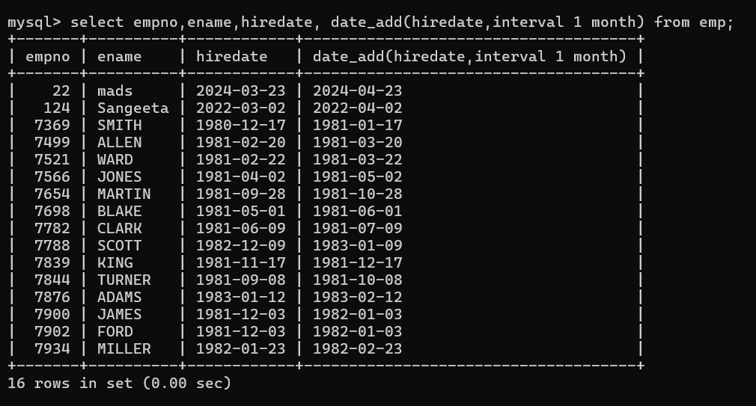

1. Write a query to get first name, hire date and experience of the employees.

Sample table: employees

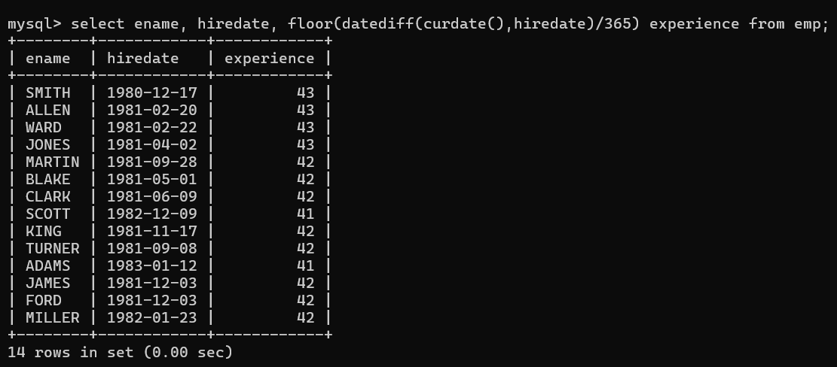

1. Write a query to get the department ID, year, and number of employees joined.

